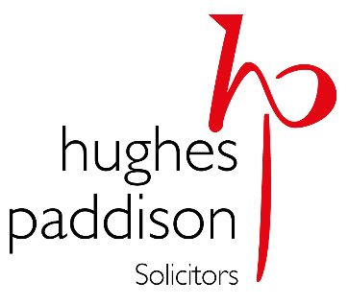
GUIDANCE FOR VISITORS TO HUGHES PADDISON OFFICES

We welcome clients into our offices. Clients wishing to visit are encouraged to make an appointment. To make an appointment please call 01242 574244.
Please note that if you are coming into our offices and are feeling unwell with any of the COVID-19 symptoms then you should not attend our offices. Where appropriate we will be happy to make alternative meeting arrangements via video conference or telephone.
When you arrive at our offices, please observe the current Government Guidelines, our office protocols and please also follow directions given to you by our staff. Please ensure you use the hand sanitisers provided on entering and moving around within our premises.
Thank you for working with us to ensure a COVID-19 secure environment. If you have any concerns, or questions please raise them with the person you are meeting.
Thank you.

